Real Talk: Corona Virus COVID-19

The best way to prevent Corona Virus is to WASH YOUR HANDS!

Wash your hands for at least 20 seconds (the time it takes to sing the Happy Birthday song twice) frequently with warm soap and water, and dry with paper towel or clean towel. Masks DO NOT help prevent Corona Virus.
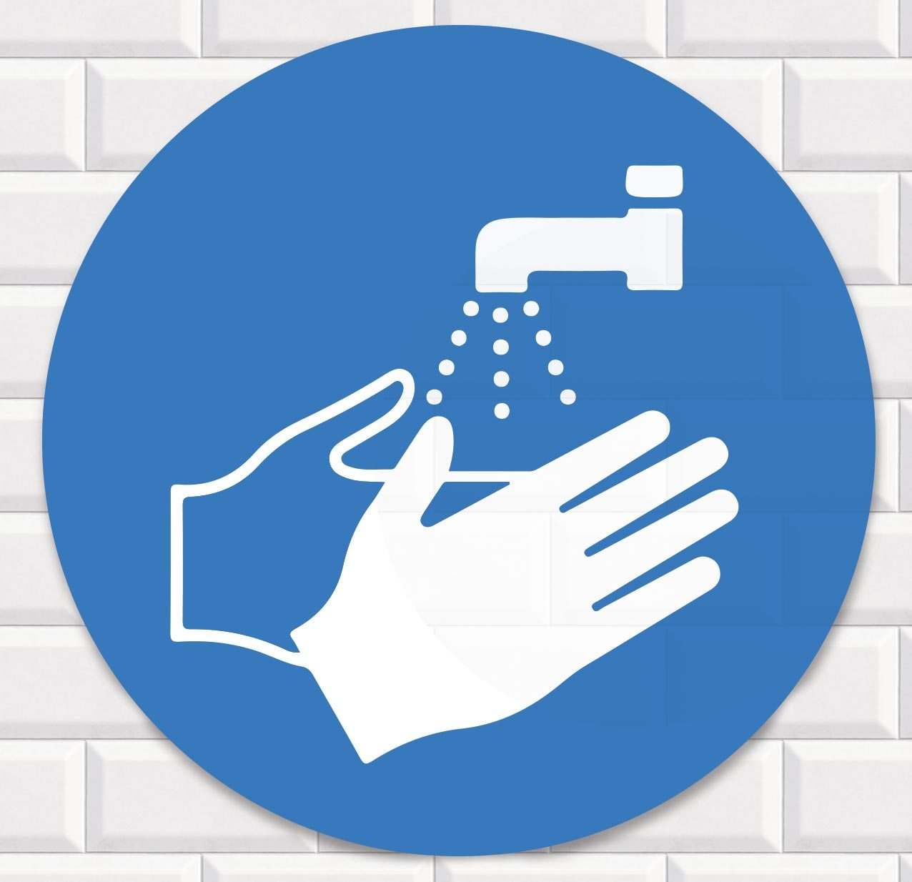

Don’t Panic! Remember your Neighbors!
Most people (80%) who get Corona Virus will not get very sick. Remember to check on your at-risk loved ones and elders.

Avoid Large Crowds as Much as Possible
Avoid crowds and public spaces if possible. If you live with other people, remember that Corona Virus is usually caught by someone within 6 feet of you.

Stay Informed
Get your health information from a reliable source. There is a lot of misinformation out there. Do not apply bleach spray, chlorine, or garlic spray onto your skin.will not help prevent Corona Virus and can be dangerous. A good, reliable source is cdc.gov.
(over)
Real Talk: Corona Virus COVID-19

The best way to prevent Corona Virus is to WASH YOUR HANDS!

Wash your hands for at least 20 seconds (the time it takes to sing the Happy Birthday song twice) frequently with warm soap and water, and dry with paper towel or clean towel. Masks DO NOT help prevent Corona Virus.

Don’t Panic! Remember your Neighbors!
Most people (80%) who get Corona Virus will not get very sick. Remember to check on your at-risk loved ones and elders.

Avoid Large Crowds as Much as Possible
Avoid crowds and public spaces if possible. If you live with other people, remember that Corona Virus is usually caught by someone within 6 feet of you.

Stay Informed
Get your health information from a reliable source. There is a lot of misinformation out there. Do not apply bleach spray, chlorine, or garlic spray onto your skin.will not help prevent Corona Virus and can be dangerous. A good, reliable source is cdc.gov.
(over)
Real Talk: Corona Virus COVID-19

The best way to prevent Corona Virus is to WASH YOUR HANDS!

Wash your hands for at least 20 seconds (the time it takes to sing the Happy Birthday song twice) frequently with warm soap and water, and dry with paper towel or clean towel. Masks DO NOT help prevent Corona Virus.

Don’t Panic! Remember your Neighbors!
Most people (80%) who get Corona Virus will not get very sick. Remember to check on your at-risk loved ones and elders.

Avoid Large Crowds as Much as Possible
Avoid crowds and public spaces if possible. If you live with other people, remember that Corona Virus is usually caught by someone within 6 feet of you.

Stay Informed
Get your health information from a reliable source. There is a lot of misinformation out there. Do not apply bleach spray, chlorine, or garlic spray onto your skin.will not help prevent Corona Virus and can be dangerous. A good, reliable source is cdc.gov.
(over)

What To Do IF You Get Sick:
Resources

Cough and Sneeze into your Inner Elbow
This helps prevent your spit droplets from spreading, which is how Corona Virus is transmitted.

What to do if You Get Sick
First, call your healthcare provider (don’t just show up) to explain your symptoms and get advice. If you don’t have a healthcare provider, see the resources below. In general, do not go to the ER unless you are having a severe or
life threatening emergency.

Corona Virus Hotlines
Missouri Hotline: (877) 435-8411 -24 hours a day
St. Louis Hotline: (314) 657-1499 -Mon-Fri 8-5pm

If you don’t have a healthcare provider, these groups provide healthcare for people who are low income or uninsured:

- Affinia Healthcare Appt. Line: 314-814-8700
- CHIPS Health Center: 314- 652-9231 x10
- Care STL: (314) 633-6363
- People’s Clinic: (314) 367-7848
- Family Care Health Centers:
Southside:314-353-5190 Northside:314-531-5444

Compiled by Karen House, Source: cdc.gov
What To Do IF You Get Sick:
Resources

Cough and Sneeze into your Inner Elbow
This helps prevent your spit droplets from spreading, which is how Corona Virus is transmitted.

What to do if You Get Sick
First, call your healthcare provider (don’t just show up) to explain your symptoms and get advice. If you don’t have a healthcare provider, see the resources below. In general, do not go to the ER unless you are having a severe or
life threatening emergency.

Corona Virus Hotlines
Missouri Hotline: (877) 435-8411 -24 hours a day
St. Louis Hotline: (314) 657-1499 -Mon-Fri 8-5pm

If you don’t have a healthcare provider, these groups provide healthcare for people who are low income or uninsured:

- Affinia Healthcare Appt. Line: 314-814-8700
- CHIPS Health Center: 314- 652-9231 x10
- Care STL: (314) 633-6363
- People’s Clinic: (314) 367-7848
- Family Care Health Centers:
Southside:314-353-5190 Northside:314-531-5444

Compiled by Karen House, Source: cdc.gov
What To Do IF You Get Sick:
Resources

Cough and Sneeze into your Inner Elbow
This helps prevent your spit droplets from spreading, which is how Corona Virus is transmitted.

What to do if You Get Sick
First, call your healthcare provider (don’t just show up) to explain your symptoms and get advice. If you don’t have a healthcare provider, see the resources below. In general, do not go to the ER unless you are having a severe or
life threatening emergency.

Corona Virus Hotlines
Missouri Hotline: (877) 435-8411 -24 hours a day
St. Louis Hotline: (314) 657-1499 -Mon-Fri 8-5pm

If you don’t have a healthcare provider, these groups provide healthcare for people who are low income or uninsured:

- Affinia Healthcare Appt. Line: 314-814-8700
- CHIPS Health Center: 314- 652-9231 x10
- Care STL: (314) 633-6363
- People’s Clinic: (314) 367-7848
- Family Care Health Centers:
Southside:314-353-5190 Northside:314-531-5444

Compiled by Karen House, Source: cdc.gov

